Design Brief

Contents

Executive Summary 2

Project Documentation 2

Timeline 3

Problem Statement 3

Ideation & Morphological Table 4

1. Motor type 4

2. Steering Angle Sensor Type 4

3. Steering Angle Sensor Position 4

4. Coupling Position 4

5. Motor to Steering Coupling 4

6. Disengagement 4

Scoring Matrix 5

1. Performance 5

2. Precision & Accuracy 5

3. Reliability & Durability 5

4. Complexity & Integration 5

5. Cost-Effectiveness 5

6. Maintainability 5

7. Safety 5

8. Modularity 5

9. Scalability & Flexibility 6

Issues & Feedback 6

*Detailed process documentation, including ideation, morphological table and scoring matrix to determine possible designs. This would be justified by calculations and drawings encapsulated in a report.*

# Executive Summary

The project involves designing a mechatronic system which enables the steering mechanism on the 2022-2023 UTS Motorsports FSAE car to be controlled autonomously. The steering system consists of a steering wheel, universal joint linkages and a steering column into a worm drive steering rack.

The engineer must consider ergonomic constraints as the vehicle must be both manually and autonomously operated. Further, competition regulations must be kept in mind throughout the design process so the final solution can form part of a fully rules-compliant competition car.

Successful completion of this project allows this year’s team to migrate to the newer 2022/23 chassis and progress towards our goal of having a rules compliant autonomous Formula SAE car. The stakeholders involved include UTS Motorsports, UTS and team sponsors.

# Project Documentation

The project scope includes the following design documentation:

* Timeline
* Ideation
* Morphological Table
* Scoring Matrix

## Timeline

Below is a flow chart of the process we followed to achieve the final design.

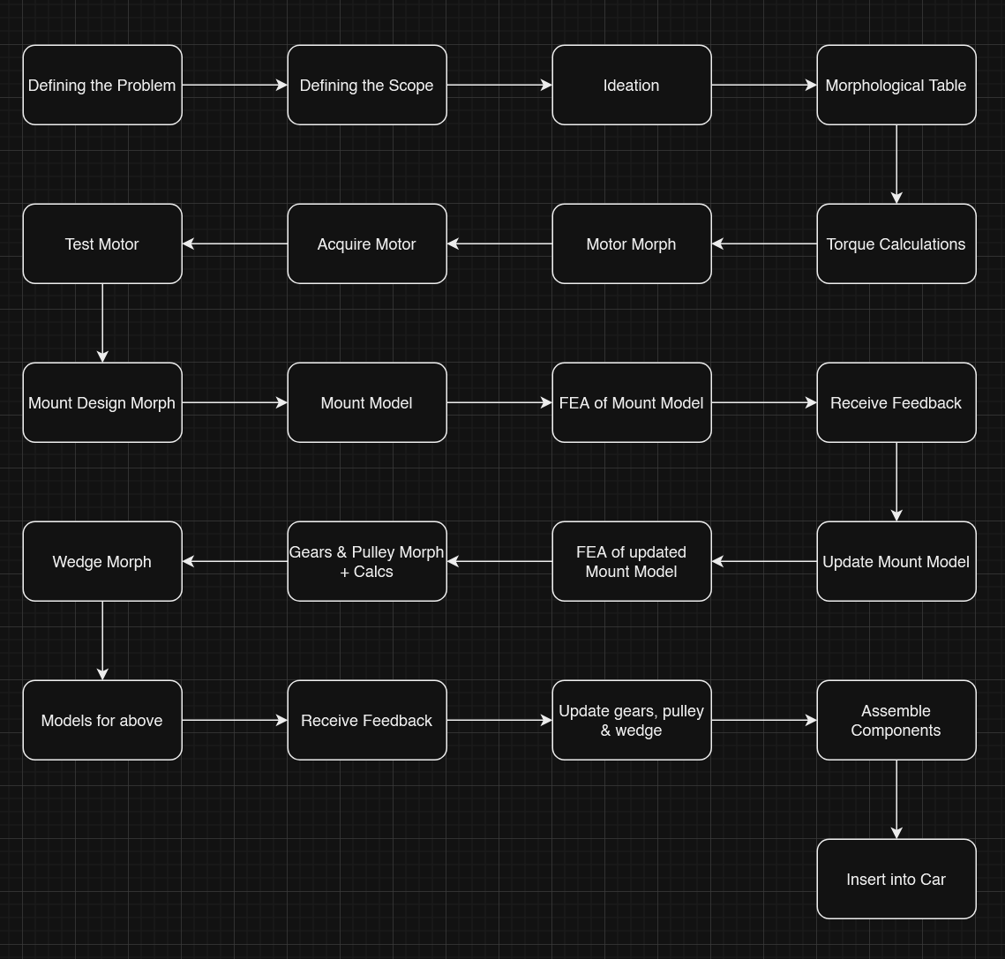

Figure : Timeline Flowchart

First few sessions were spent defining the problem into a problem statement and creating the scope for the project.

## Problem Statement

Design an electromechanical control system capable of rotating the steering column of the UTSMA autonomous car, ensuring it fits safely and ergonomically within the footwell while complying with the FSAE competition regulations.

## Ideation & Morphological Table

Ideating followed the basic principles of discussing how the product could be broken down into sub-assemblies which can be solved individually. These segments include:

### Motor type

This was mainly condensed to two options: A BLDC or a Stepper. Finally, a BLDC Motor was selected: AK80-9.

### Steering Angle Sensor Type

Was taken out of consideration as the selected motor included built-in sensors.

### Steering Angle Sensor Position

Effective placement was to be on underside of the floor, directly beneath the steering column.

### Coupling Position

Positioned at the bottom of the steering column to make full use of space constraints with Cockpit Template (Refer to FSAE rules).

### Motor to Steering Coupling

Belt and Pulley drive

### Disengagement

Since the selected motor is backdrivable, the system can be electrically disengaged. Therefore, the considered idea of a mechanical disengage was discarded.

## Scoring Matrix

Suitable and relevant components were selected from each of the morphological table categories and made into defined “designs”. This would be rated by the following criteria:

### Performance

Delivering the calculated amount of torque without any compromise to the motor.

### Precision & Accuracy

The ability of the steering system to precisely follow the desired path and make accurate adjustments.

### Reliability & Durability

The system’s ability to consistently perform under various operating conditions and resist wear and tear.

### Complexity & Integration

How easy the system is to design, implement, and integrate with the rest of the vehicle, including sensors, controllers, and other hardware.

### Cost-Effectiveness

The overall cost of the steering system, including the cost of components, manufacturing, and maintenance.

### Maintainability

The ease with which the system can be repaired, upgraded, or serviced.

### Safety

Built-in safety features, fail-safes, and redundancy to prevent system failures from compromising the vehicle’s performance.

### Modularity

Ease of create a modular variant, that is compliant with FSAE rules.

### Scalability & Flexibility

Ease of using current design to be used in future iterations.

Using these criteria the following design was proposed:

BLDC controlled using magnetic rotary encoder (being positioned directly at the end of the motor shaft). It would be situated at the bottom of the floor, driven by a set of gears and pulleys. The system can be disengaged by electrically disconnecting the motor, as it is backdrivable.

However, with a slight change in motors led to the sensor being discarded.

# Issues & Feedback

* Motor torque calculations took a long time to confirm and validate, resulting in the team getting access to it a couple of weeks in.
* Alterations made to the designs were not being documented and justified.
* Communications were not consistent in the first few weeks, but afterwards was resolved appropriately. Could have solved this a lot quicker.
* Issues with team members not showing up to meetings and not living up to agreements.
* Issues with final design not being in accordance with space constraints (refer to CAD and FSAE rules).
* Difficulty to come to decisions about final design.